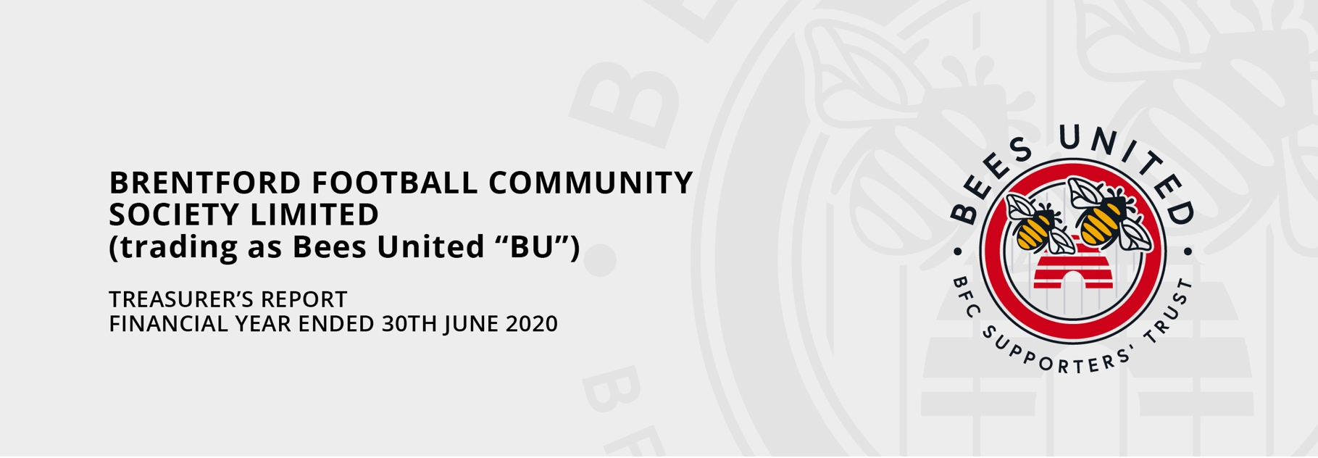

First and foremost, I would like to say a huge thank you to the near 400 members of BU who, despite membership now being free, continue to donate on a regular basis through standing orders. Those donations generated the vast majority of our total income for the year (£26,140).
Following the publication of the Stadium Book, “Bees, Battles, Buckets and Ballot Boxes”, which was sent to nearly 2,000 members for Christmas, we received a number of enquiries from Members wishing to make a donation to BU (and many thanks to those of you that did). To make these types of donations simpler, whether one-off or on a regular basis, we are looking to have a donation “button” on our website and possibly on other media – and hopefully I will have more news on that at the AGM.
On the book, we have been so successful in our efforts to reconnect with “lost” members, the BU Board have commissioned a second print run which will be distributed over the coming months to those members who missed out. Many thanks to John Scott, our Membership and Technology Secretary for all his hard work in reconnecting and cleaning up the membership database.
I would also like to take this opportunity to thank the Jazz Club for their invaluable support over the years and for their significant financial donation again in the last year. Sadly, with the gates finally closing on Griffin Park, the Jazz Club will need to find a new home and I wish them luck with that and continued success in the future. On behalf of Bees United, thank you to all concerned.
These are certainly good times to be a Brentford supporter. In the majority of matches the football is an absolute joy to watch and we are enjoying our most successful period since the 1930s. As I write this report the Bees are in a good position in the League and well placed to secure a top two spot and automatic promotion. Let’s hope that when fans are able to return to football, we are going to the new stadium to watch Brentford playing Premier League Football.
The success on the pitch is based on solid foundations off it and the Club mantra of Bee Together. The Club seems to be in good hands and in rude health. You may wonder then if Bees United is still relevant, twenty years after it was formed, and if it still needs to raise funds. BU plays an important and influential part of the Brentford family. We retain a place on the Board of the Football Club and, having played a vital role in the move to Lionel Road (read the book) keeps a veto on any future Ground move. The donations that members generously continue to make allows BU to not only cover Administrative costs but to fund projects (some examples are included later) and maintain/build a “war chest” in the eventuality that BU is needed to again step in to run the Club. Of course, we all hope that eventuality never happens.
The BU Accounts for 2020 have recently been finalised and they will be published on the BU website shortly. However, I would like to give you all some headlines and key points for 2020 – and a brief look ahead at the Accounts for 2021 as this has been a very busy period for BU.

Independence and Transparency
The Board has proposed (and recommends) a resolution that the Accounts for the current year, ended 30th June 2021, are not audited. This is a standard resolution that is usually proposed and carried each year. To ensure confidence in the Accounts, they are prepared and signed-off by independent Accountants – Levy & Partners Limited. Given this level of independence the Board believes that there is not the need for (and added cost of) an audit.
The resolution was missed last year. As a result, the Accounts for 2020 will be audited.
Our accounts are submitted to the FCA (Financial Conduct Authority) and are saved on the BU Website.

Summary Accounts to 30 June 2020 (Subject to Final Accounts Sign-Off).
Income | £
Members Donations (STOs) | 23,613
Other Donations (net) | 2,204
Bank Interest | 112
Other Income | 148
 | 26,079
Expenditure
Professional Fees - Engage Convert (New Website) | 9,000
Professional Fees - Gydeline (GDPR Compliance) | 935
Advance for Book Publication | 2,880
Levy & Partners (Accounting Fees) | 1,800
AGM Costs | 1,195
Insurance | 900
Sundry Expenses | 350
Tax | 22
 | 17,082
Net Surplus for the Year | 8,995

For comparison, in 2018/19, the previous year, we had a Net Surplus of £13,927 (Income £25,867 and Expenditure £11,940). As well as the usual Administrative costs (Accounting Fees, Insurance and the AGM), the big spend items for 2019/20 have been the investment in updating and improving the BU Website, guidance and support on GDPR Compliance and an initial payment for the Stadium book.
BU has Assets totalling a little over £1m (loans to the Club and Cash at Bank)
The full accounts will be published on the BU website as soon as they are available.

Look ahead to this year’s accounts
With only 3 months to the end of the current financial year (and an unusually high level of spend in the year) I want to give BU members a look at where we are likely to be for this year’s accounts. We are expecting a Net Deficit for 2021 of around £15,000.
Member’s donations remain at a healthy level (expected to be circa £23,000) but expenditure has increased significantly and is likely to be around £38,000 – including £31,000 on the publication and distribution of books (including digital versions).
Our Budget for the following year, 2021/22, shows a return to a Net Surplus of around £10,000.

Conclusion
BU continues to attract new members, re-connect with “lost” members and is in good shape financially. Thanks to its membership, we remain an active and influential member of the Brentford family.

Jim Walsh
Treasurer
Bees United

